Activity 5.1: Supervised Learning using Decision Tree & Random Forest (Playing Golf Dataset)

Name:_______________ Date:________________
Section:______________ Score:_______________

- Objectives

Students should be able to:
- Understand Supervised Learning (Classification)
- Apply Decision Tree (J48) and Random Forest in WEKA
- Evaluate model performance using metrics

- Learning Outcomes (Skills/Competencies)

Students will be able to:
- Build classification models in WEKA
- Interpret decision trees and ensemble models
- Explain evaluation metrics conceptually

- Exercises (Laboratory Activity)

PART 1: Data Loading and Inspection

Instructions:
- Open WEKA Explorer
- Click Preprocess tab
- Click Open file
- Load: weather.nominal.arff

Questions
Q1. How many instances are in the dataset?
Answer: There are 14 instances in the dataset.
Q2. What is the class attribute?
Answer: The class attribute is play.
Q3. What type of problem is this? (Classification or Clustering problem)
Answer: This is a classification problem since the task is to predict whether play will be yes or no.

PART 2: Decision Tree (J48) – Training Set

Instructions:
- Go to Classify tab. Choose → trees → J48
- Under Test Options → select:
✔ Use training set (The training set is the collection of examples (rows in your dataset) used to fit the model.)
- Click Start

Questions
Q4. What is the accuracy using the training set?
Answer: The training set accuracy is 100%, which means all 14 instances were classified correctly.
Q5. Why is the accuracy very high?
Answer: The result is very high because the same dataset was used both for learning and testing. Since the data is small, the model can follow the training patterns almost perfectly.

PART 3: Decision Tree (J48) – Cross Validation

Instructions:
- Keep J48 selected
- Change Test Options →
✔ 10-fold cross-validation
- Click Start

Questions
Q6. What is the accuracy using cross-validation?
Answer: The cross-validation accuracy is 64.29%, or 9 correct predictions out of 14.
Q7. Why did the accuracy decrease?
Answer: The accuracy went down because cross-validation checks the model using data it has not seen during training. That makes the result more realistic than testing on the training set only.

PART 4: Decision Tree Visualization and Structure

Instructions:
- In the result list, right-click J48 result
- Click Visualize tree

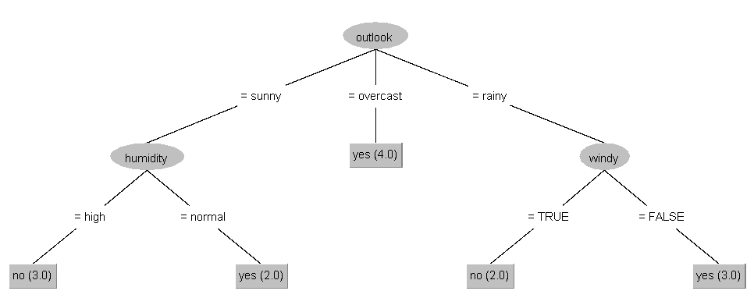
Identify the Parts of the Tree:
Q8. What is the root node?
Answer: The root node is outlook.
Q9. What are the internal nodes?
Answer: The internal nodes are humidity and windy.
Q10. What are the leaf nodes?
Answer: The leaf nodes are the final outputs, which are play = yes and play = no.

Understanding the Tree
Q11. Write one IF-THEN rule from the tree:
Example answer: IF outlook = overcast → play = yes
Answer: One example rule is: IF outlook = rainy AND windy = false, THEN play = yes.
Q12. How does the tree make decisions?
Answer: The decision tree works by checking one condition after another, starting from the top node and moving downward. When it reaches a leaf, that leaf gives the final prediction.

PART 5: Random Forest (Comparison: Training Set vs Cross-Validation)

A. Random Forest – Training Set

Instructions:
  - Click Choose → trees → RandomForest
  - Under Test Options, select:
  - Use training set
  - Keep default settings
  - Click Start

Guide Questions

Q13. What is the accuracy using the training set?
Answer: For Random Forest, the training set accuracy is 100% or 14 out of 14 correctly classified instances.

Q14. Why is the accuracy high?
Answer: The accuracy is high because the model is evaluated using the same records it learned from, so it can match the dataset very closely.

B. Random Forest – Cross-Validation

Instructions:
- Keep RandomForest selected
- Change Test Options →
- ✔ 10-fold cross-validation
- Click Start

Guide Questions

Q15. What is the accuracy using cross-validation?
Answer: The Random Forest accuracy under 10-fold cross-validation is 50%, or 7 correct predictions out of 14.

Q16. Compare Random Forest results in terms of accuracy (Training vs Cross-Validation).
Answer: Training set -> 100%. Cross-validation -> 50%. This means the model looks perfect on familiar data, but its performance becomes weaker when tested on unseen parts of the dataset.
Training set →
Cross-validation →

C. Conceptual Understanding

Q17. Can you visualize the Random Forest?
Answer: Not in the same simple way as J48. A Random Forest is made up of many trees, so it is harder to show as one easy diagram.

Q18. How is Random Forest different from J48?
Answer: J48 creates only one decision tree, so it is easier to read and explain. Random Forest combines many trees, which usually makes it stronger but also harder to interpret.

J48 →
Random Forest →

Q19. Why is Random Forest more robust than J48?
Answer: Random Forest is more robust because it combines the outputs of multiple trees instead of relying on just one. This helps reduce overfitting and makes the model more stable.

Q20. Based on cross-validation, which model is more reliable?
Answer: Based on the cross-validation results, J48 is more reliable in this activity because it achieved a higher accuracy than Random Forest.

PART 6: Evaluation Metrics
Instructions:
Look at WEKA output and identify metrics.

Guide Questions
Q10. What is Accuracy? Answer: Accuracy is the percentage of predictions that were correct.

Q11. What is RMSE (Root Mean Squared Error)? Answer: RMSE is a measure of prediction error. It shows how far the predicted values are from the actual values, and bigger errors have more effect on the result.

Q12. What is MAE (Mean Absolute Error)? Answer: MAE is the average of the absolute differences between the predicted values and the actual values.

Q13. What is R² (Coefficient of Determination)? Answer: R2 tells us how much of the variation in the target can be explained by the model. The closer it is to 1, the better the fit.

Q14. Which metrics are more relevant for this dataset? Answer: Since this is a classification dataset, the more useful metrics are accuracy, confusion matrix, precision, and recall.

- Glossary
- Supervised Learning – Uses labeled data
- Decision Tree – Rule-based classification model
- Random Forest – Ensemble of decision trees
- Accuracy – Correct predictions percentage
- Training set – The data used to teach the model. Example: practice questions before an exam.
- Model – The learned structure or rules created from the training set. Example: the decision tree built by J48.
- Unseen data – Data not used in training, reserved for testing. Example: the actual exam questions.
- Cross‑validation – A method of testing generalization by rotating which data is unseen. Example: rotating practice questions among students so each faces new ones.
- Overfitting – When a model memorizes the training set instead of learning general patterns. Example: a student memorizing answers word‑for‑word but failing on new questions.
- Generalization – The ability of a model to apply what it learned to new, unseen data. Example: understanding concepts so you can answer different exam questions.
- J48 – WEKA’s implementation of the C4.5 decision tree algorithm. Builds a single tree that is easy to interpret but prone to overfitting.

RUBRIC FOR DATA MINING LAB ACTIVITIES

Criteria | 4 – Excellent | 3 – Very Good | 2 – Satisfactory | 1 – Needs Improvement | Score
Technical Skills | Performs all required tasks correctly and independently | Performs tasks with minor oversight | Performs tasks with some guidance | Has difficulty performing tasks
Understanding of Concepts | Demonstrates clear and deep understanding of concepts | Shows good understanding of concepts | Shows basic understanding | Shows limited understanding
Creativity and Originality | Shows original thinking, unique ideas, and personal insight | Shows some creativity and personal input | Shows minimal creativity | Very little originality
Application of Concepts | Applies concepts effectively to practical situations | Applies concepts with minor confusion | Makes simple applications | Weak or incorrect application
Organization and Presentation | Work is neat, well-organized, and easy to follow | Mostly organized with minor issues | Adequately organized | Poorly organized
TOTAL

